Hibernate Tutorial

This hibernate tutorial provides in-depth concepts of Hibernate Framework with simplified examples. It was started in 2001 by Gavin King as an alternative to EJB2 style entity bean. The stable release of Hibernate till July 16, 2014, is [hibernate 4.3.6](http://hibernate.org/orm/downloads/). It is helpful for beginners and experienced persons.

**Hibernate Framework**

Hibernate framework simplifies the development of java application to interact with the database. Hibernate is an open source, lightweight, [ORM (Object Relational Mapping)](http://en.wikipedia.org/wiki/Object-relational_mapping) tool.

An ORM tool simplifies the data creation, data manipulation and data access. It is a programming technique that maps the object to the data stored in the database.

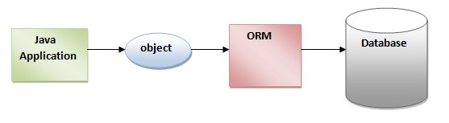

The ORM tool internally uses the JDBC API to interact with the database.

Advantages of Hibernate Framework

There are many advantages of Hibernate Framework. They are as follows:

**1) Opensource and Lightweight:** Hibernate framework is opensource under the LGPL license and lightweight.

**2) Fast performance:** The performance of hibernate framework is fast because cache is internally used in hibernate framework. There are two types of cache in hibernate framework first level cache and second level cache. First level cache is enabled bydefault.

**3) Database Independent query:** HQL (Hibernate Query Language) is the object-oriented version of SQL. It generates the database independent queries. So you don't need to write database specific queries. Before Hibernate, If database is changed for the project, we need to change the SQL query as well that leads to the maintenance problem.

**4) Automatic table creation:** Hibernate framework provides the facility to create the tables of the database automatically. So there is no need to create tables in the database manually.

**5) Simplifies complex join:** To fetch data form multiple tables is easy in hibernate framework.

**6) Provides query statistics and database status:** Hibernate supports Query cache and provide statistics about query and database status.

Hibernate Architecture

1. [Hibernate Architecture](http://www.javatpoint.com/hibernate-architecture)
2. [Elements of Hibernate Architecture](http://www.javatpoint.com/hibernate-architecture#elements)
   1. [SessionFactory](http://www.javatpoint.com/hibernate-architecture#e1)
   2. [Session](http://www.javatpoint.com/hibernate-architecture#e2)
   3. [Transaction](http://www.javatpoint.com/hibernate-architecture#e3)
   4. [ConnectionProvider](http://www.javatpoint.com/hibernate-architecture#e4)
   5. [TransactionFactory](http://www.javatpoint.com/hibernate-architecture#e5)

The Hibernate architecture includes many objects persistent object, session factory, transaction factory, connection factory, session, transaction etc.

There are 4 layers in hibernate architecture java application layer, hibernate framework layer, backhand api layer and database layer.Let's see the diagram of hibernate architecture:

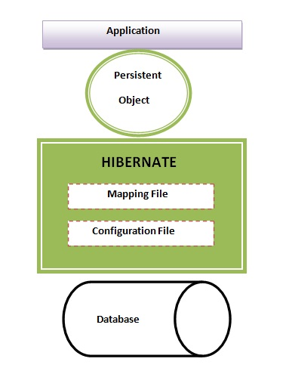

This is the high level architecture of Hibernate with mapping file and configuration file.

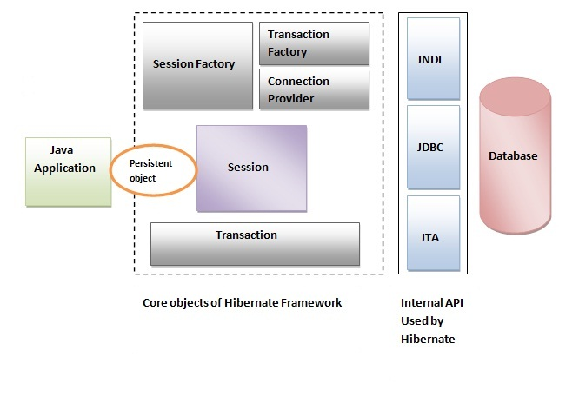

Hibernate framework uses many objects session factory, session, transaction etc. alongwith existing Java API such as JDBC (Java Database Connectivity), JTA (Java Transaction API) and JNDI (Java Naming Directory Interface).

Elements of Hibernate Architecture

|  |
| --- |
| For creating the first hibernate application, we must know the elements of Hibernate architecture. They are as follows: |

**SessionFactory**

The SessionFactory is a factory of session and client of ConnectionProvider. It holds second level cache (optional) of data. The org.hibernate.SessionFactory interface provides factory method to get the object of Session.

**Session**

The session object provides an interface between the application and data stored in the database. It is a short-lived object and wraps the JDBC connection. It is factory of Transaction, Query and Criteria. It holds a first-level cache (mandatory) of data. The org.hibernate.Session interface provides methods to insert, update and delete the object. It also provides factory methods for Transaction, Query and Criteria.

**Transaction**

The transaction object specifies the atomic unit of work. It is optional. The org.hibernate.Transaction interface provides methods for transaction management.

**ConnectionProvider**

It is a factory of JDBC connections. It abstracts the application from DriverManager or DataSource. It is optional.

**TransactionFactory**

It is a factory of Transaction. It is optional.

# SQL Dialects in Hibernate

For connecting any hibernate application with the database, you must specify the SQL dialects. There are many Dialects classes defined for RDBMS in the org.hibernate.dialect package. They are as follows:

|  |  |
| --- | --- |
| **RDBMS** | **Dialect** |
| Oracle (any version) | org.hibernate.dialect.OracleDialect |
| Oracle9i | org.hibernate.dialect.Oracle9iDialect |
| Oracle10g | org.hibernate.dialect.Oracle10gDialect |
| MySQL | org.hibernate.dialect.MySQLDialect |
| MySQL with InnoDB | org.hibernate.dialect.MySQLInnoDBDialect |
| MySQL with MyISAM | org.hibernate.dialect.MySQLMyISAMDialect |
| DB2 | org.hibernate.dialect.DB2Dialect |
| DB2 AS/400 | org.hibernate.dialect.DB2400Dialect |
| DB2 OS390 | org.hibernate.dialect.DB2390Dialect |
| Microsoft SQL Server | org.hibernate.dialect.SQLServerDialect |
| Sybase | org.hibernate.dialect.SybaseDialect |
| Sybase Anywhere | org.hibernate.dialect.SybaseAnywhereDialect |
| PostgreSQL | org.hibernate.dialect.PostgreSQLDialect |
| SAP DB | org.hibernate.dialect.SAPDBDialect |
| Informix | org.hibernate.dialect.InformixDialect |
| HypersonicSQL | org.hibernate.dialect.HSQLDialect |
| Ingres | org.hibernate.dialect.IngresDialect |
| Progress | org.hibernate.dialect.ProgressDialect |
| Mckoi SQL | org.hibernate.dialect.MckoiDialect |
| Interbase | org.hibernate.dialect.InterbaseDialect |
| Pointbase | org.hibernate.dialect.PointbaseDialect |
| FrontBase | org.hibernate.dialect.FrontbaseDialect |
| Firebird | org.hibernate.dialect.FirebirdDialect |